**DLD LAB 09 – IN LAB**

**Task 01:**

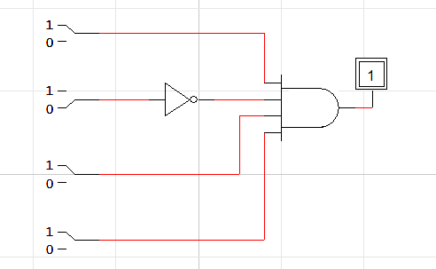

**Task 02(b):**

|  |  |  |  |  |  |  |  |  |  |  |  |
| --- | --- | --- | --- | --- | --- | --- | --- | --- | --- | --- | --- |
| **E** | **A** | **B** | **C** | **Y1** | **Y2** | **Y3** | **Y4** | **Y5** | **Y6** | **Y7** | **Y8** |
| 0 | x | x | x | 0 | 0 | 0 | 0 | 0 | 0 | 0 | 0 |
| 1 | 0 | 0 | 0 | 1 | 0 | 0 | 0 | 0 | 0 | 0 | 0 |
| 1 | 0 | 0 | 1 | 0 | 1 | 0 | 0 | 0 | 0 | 0 | 0 |
| 1 | 0 | 1 | 0 | 0 | 0 | 1 | 0 | 0 | 0 | 0 | 0 |
| 1 | 0 | 1 | 1 | 0 | 0 | 0 | 1 | 0 | 0 | 0 | 0 |
| 1 | 1 | 0 | 0 | 0 | 0 | 0 | 0 | 1 | 0 | 0 | 0 |
| 1 | 1 | 0 | 1 | 0 | 0 | 0 | 0 | 0 | 1 | 0 | 0 |
| 1 | 1 | 1 | 0 | 0 | 0 | 0 | 0 | 0 | 0 | 1 | 0 |
| 1 | 1 | 1 | 1 | 0 | 0 | 0 | 0 | 0 | 0 | 0 | 1 |

**Task 03(b):**

|  |  |  |  |  |  |  |  |  |  |  |
| --- | --- | --- | --- | --- | --- | --- | --- | --- | --- | --- |
| **Inputs** | | | | **Outputs** | | | | | | |
| **A3** | **A2** | **A1** | **A0** | **a** | **b** | **c** | **d** | **e** | **f** | **g** |
| 0 | 0 | 0 | 0 | 1 | 1 | 1 | 1 | 1 | 1 | 0 |
| 0 | 0 | 0 | 1 | 0 | 1 | 1 | 0 | 0 | 0 | 0 |
| 0 | 0 | 1 | 0 | 1 | 1 | 0 | 1 | 1 | 0 | 1 |
| 0 | 0 | 1 | 1 | 1 | 1 | 1 | 1 | 0 | 0 | 1 |
| 0 | 1 | 0 | 0 | 0 | 1 | 1 | 0 | 0 | 1 | 1 |
| 0 | 1 | 0 | 1 | 1 | 1 | 1 | 1 | 0 | 1 | 1 |
| 0 | 1 | 1 | 0 | 1 | 0 | 1 | 1 | 1 | 1 | 1 |
| 0 | 1 | 1 | 1 | 1 | 0 | 1 | 0 | 0 | 0 | 0 |
| 1 | 0 | 0 | 0 | 1 | 1 | 1 | 1 | 1 | 1 | 1 |
| 1 | 0 | 0 | 1 | 1 | 1 | 1 | 1 | 0 | 1 | 1 |